Louise Spencer
3 Kent Street
Concord, NH 03301

January 22, 2024

VIA CERTIFIED MAIL, RETURN RECEIPT REQUESTED

Rudolph Ogden, Legal Counsel
Office of the Governor
State House
107 North Main Street
Concord, NH 03301

Re: Right-to-Know/Public Records Request

Dear Mr. Ogden:

Pursuant to the New Hampshire Constitution Part I, Article 8, and New Hampshire’s Right-to-Know Law, as codified at RSA § 91-A, I, Louise Spencer (a New Hampshire resident), make the following request for records.

Requested Records

I request that the Office of the Governor (“the Office”) produce copies of the following within five business days:

- The Office’s policy or policies governing the retention, destruction and/or disposal of governmental records, including emails, texts and other direct messages (such as those in iMessage, WhatsApp, Signal, or Twitter.com), voicemail messages, instant messaging systems such as Lync or ICQ, and shared message systems such as Slack.

- Records describing or reflecting any internal protocols for responding to Right-to-Know requests. Records responsive to this part of my request may include, but are not limited to, those identifying search procedures for the direct and shared message systems referenced in (1) above.

- Records describing or reflecting any electronic software or platforms used by the the Office to search for records responsive to Right-to-Know requests, including but not limited to user manuals, policy or process documents, or other instructions or training materials.

- Records describing the storage capacity or storage capability for records generated by the Office, including technical documents and policy or procedure documents.

- All records reflecting the Office’s policies and procedures for keeping and maintaining governmental records in its custody.

Please provide all responsive records created or in effect from January 1, 2023, through the date the search is conducted.

If you are unable to produce the requested records within five business days, please provide written acknowledgement of this request and a statement of the time reasonably necessary to determine whether the request will be granted or denied.

Costs and Fees

I ask that any charges in connection with processing this request for records not exceed the actual cost of providing the copies. Please notify my counsel of any anticipated costs in excess of $100 prior to incurring such costs. In addition, should any fees otherwise established by law apply to this request for records, please notify my counsel in advance. Contact information for my counsel is provided at the end of this letter.

Guidance Regarding the Search & Processing of Requested Records

- Please search all locations and systems likely to have responsive records, regardless of format, medium, or physical characteristics.
- In conducting your search, please understand the terms “record,” “document,” and “information” in their broadest sense, to include any written, typed, recorded, graphic, printed, or audio material of any kind.
- My request for records includes any attachments to those records or other materials enclosed with those records when they were previously transmitted. To the extent that an email is responsive to my request, please include all prior messages sent or received in that email chain, as well as any attachments to the email.
- Please search all relevant records or systems containing records regarding the Office of the Governor’s business. Do not exclude records pertaining to the Office of the Governor’s business that may be contained in files, email accounts, or devices in the personal custody of your officials, such as personal email accounts or text messages.
- In the event some portions of the requested records are properly exempt from disclosure, please disclose any reasonably segregable non-exempt portions of the requested records. If a request is denied in whole, please state specifically why it is not reasonable to segregate portions of the record for release.
- Please take appropriate steps to ensure that records responsive to this request are not deleted by the Office of Governor before the completion of processing for this request. If records potentially responsive to this request are likely to be located on systems where they are subject to potential deletion, including on a scheduled basis, please take steps to prevent that deletion, including, as appropriate, by instituting a litigation hold on those records.
Conclusion

If you have any questions regarding how to construe this request for records or believe that further discussions regarding search and processing would facilitate a more efficient production of records in response to this request, please do not hesitate to contact my counsel to discuss this request. We welcome an opportunity to discuss this request with you before you undertake your search or incur duplication costs. By working together at the outset, we can decrease the likelihood of costly and time-consuming litigation in the future.
My counsels’ contact information is as follows:
- Elizabeth Haddix, Senior Counsel, American Oversight
Email: elizabeth.haddix@americanoversight.org
Phone: (252) 359-7424 ext. 1031

- Paul Twomey
Email: paultwomey@comcast.net
If possible, where the requested records are maintained in electronic format, I ask that you please provide responsive material in an electronic format by email to my counsel. Alternatively, please provide responsive material in native format or in PDF format on a USB drive. Please send any responsive material being sent by mail to American Oversight, 1030 15th Street NW, Suite B255, Washington, DC 20005. If it will accelerate release of responsive records, please also provide responsive material on a rolling basis.
We look forward to working with you on this request. If you do not understand any part of this request, please reach out to my counsel at the contact information listed above.

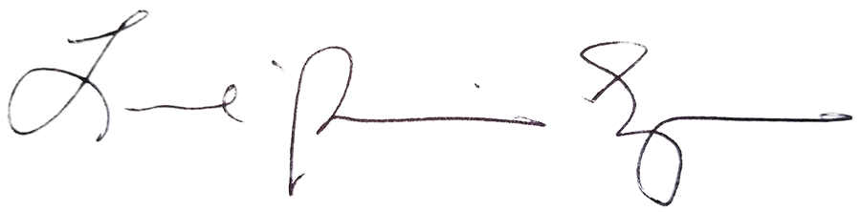
Sincerely,

Louise Spencer
Telephone: (603) 491-1795
Email: lpskentstreet@gmail.com

